**Instructions for Discussion Exercise: “Four Ways to Pay”**

This is a fun exercise that you can use in the workshop to get people thinking about their values and the variety of ways that things we use and benefit from can be paid for. Split people up into group and give them 5- 10 minutes to discuss how they think a particular structure should be paid for. The four structures we include are: dog parks, performing arts, fire protection in high risk areas, and playgrounds. The groups can decide from four different pay options:

* Paid for entirely by taxes
* Paid for mostly by taxes with a small fee for the user
* Paid for in part by taxes with a nominal fee for the user
* Paid for entirely by those who use the structure, with no tax support.

Print out these graphics and insert the exercise in the workshop wherever you feel it is appropriate for your group. (Handouts in a separate document on zip drive.)

Debrief: Ask participants to explore what it was like to be making these kinds of decisions.

* What personal experience influenced their opinion?
* Were there very divergent opinions among group members?
* What was it like discussing how to fund these structures in a group of people?
* Was it hard to find consensus? Did you learn a new perspective?

|  |  |
| --- | --- |
| **Entirely by tax revenue, which means it is available to all members of the public without any additional charge. (for example, sidewalks and city parks**) | **Mostly by tax revenue but with some fees or nominal use charges (for example, public buses, bridge tolls, late fees for library books)** |
| **Mostly by tax revenue but with larger fees paid by consumers (for example, tuition at public universities, some public golf courses, sports facilities)** | **Entirely (or almost entirely) by consumers and not available to those who don’t pay (for example, vanity license plates, building permits** |

**Dog Parks**

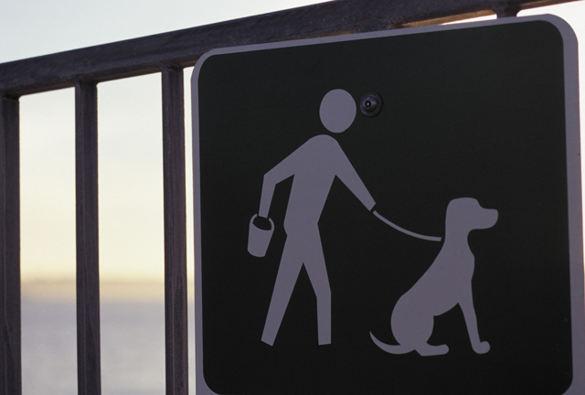

|  |  |
| --- | --- |
| **Entirely by tax revenue, which means it is available to all members of the public without any additional charge. (for example, sidewalks and city parks**) | **Mostly by tax revenue but with some fees or nominal use charges (for example, public buses, bridge tolls, late fees for library books)** |
| **Mostly by tax revenue but with larger fees paid by consumers (for example, tuition at public universities, some public golf courses, sports facilities)** | **Entirely (or almost entirely) by consumers and not available to those who don’t pay (for example, vanity license plates, building permits** |

**Performing Arts Center**



|  |  |
| --- | --- |
| **Entirely by tax revenue, which means it is available to all members of the public without any additional charge. (for example, sidewalks and city parks**) | **Mostly by tax revenue but with some fees or nominal use charges (for example, public buses, bridge tolls, late fees for library books)** |
| **Mostly by tax revenue but with larger fees paid by consumers (for example, tuition at public universities, some public golf courses, sports facilities)** | **Entirely (or almost entirely) by consumers and not available to those who don’t pay (for example, vanity license plates, building permits** |

**Fire Protection in High Risk Areas**

**C:\Documents and Settings\lizcal\Local Settings\Temporary Internet Files\Content.IE5\9Q4H8JGX\MC900057542[1].wmf**

|  |  |
| --- | --- |
| **Entirely by tax revenue, which means it is available to all members of the public without any additional charge. (for example, sidewalks and city parks**) | **Mostly by tax revenue but with some fees or nominal use charges (for example, public buses, bridge tolls, late fees for library books)** |
| **Mostly by tax revenue but with larger fees paid by consumers (for example, tuition at public universities, some public golf courses, sports facilities)** | **Entirely (or almost entirely) by consumers and not available to those who don’t pay (for example, vanity license plates, building permits** |

**Playgrounds**

